# **Link to wix site:** https://nkhamu001.wixsite.com/tutorial5

Write a short reflection on the recreation of your website from manual coding to using a CMS, of 300-500 words considering the following:

**Key differences in the design and development process between your original HTML site and the CMS version**

Rebuilding Mu’s Books from a manually coded HTML and CSS site to a CMS version on Wix had a significant difference in both the design and development process. Initially, creating the site through HTML and CSS required me to have a general understanding of website structure and styling logic. I had to hard code every element from the layout to colour theme I used throughout the store site. Having said that, although manually coding the bookstore website was more time-consuming, it has developed my experience working with these two coding languages. On the other hand, the CMS version offered a more intuitive, visual approach through drag and drop functionality. This meant that instead of focusing on syntax and error handling, I was able to dedicate some time to more front facing business operations, such as branding of the store, user interactions on different devices and content updates (adding more products and categories), which are now automated and managed on the backend through the Wix CMS.

**What design choices did you change in your CMS version and why? Include screenshots of at least three features you changed (screenshots of the original HTML site and your updated Wix site)**

As I worked through the development of my Wix site, several design choices were changed to better reflect Mu’s Books. Firstly, I switched to a classic, clean theme with a more cohesive colour palette and readable font in order to enhance professionalism and visual appeal.

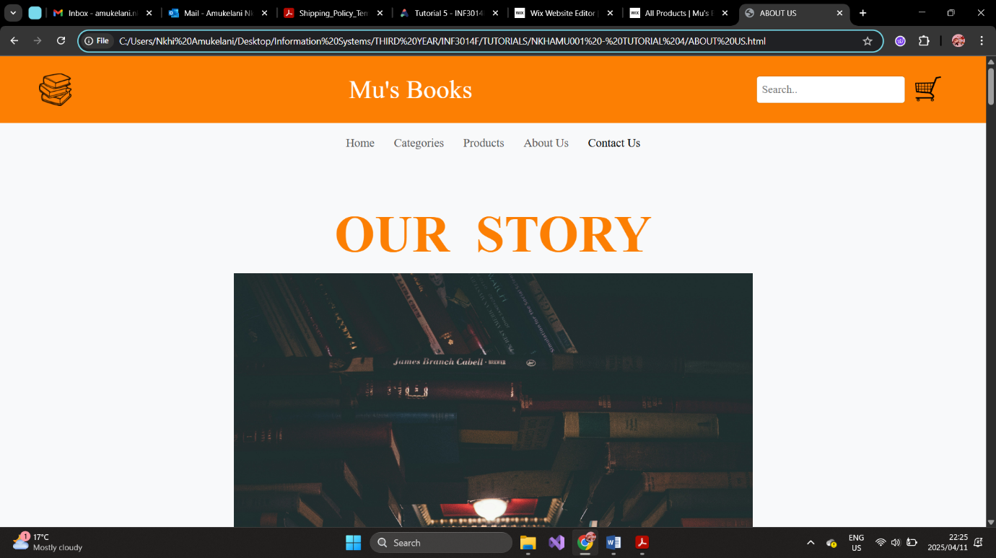

Figure 1: Initial Colour Scheme

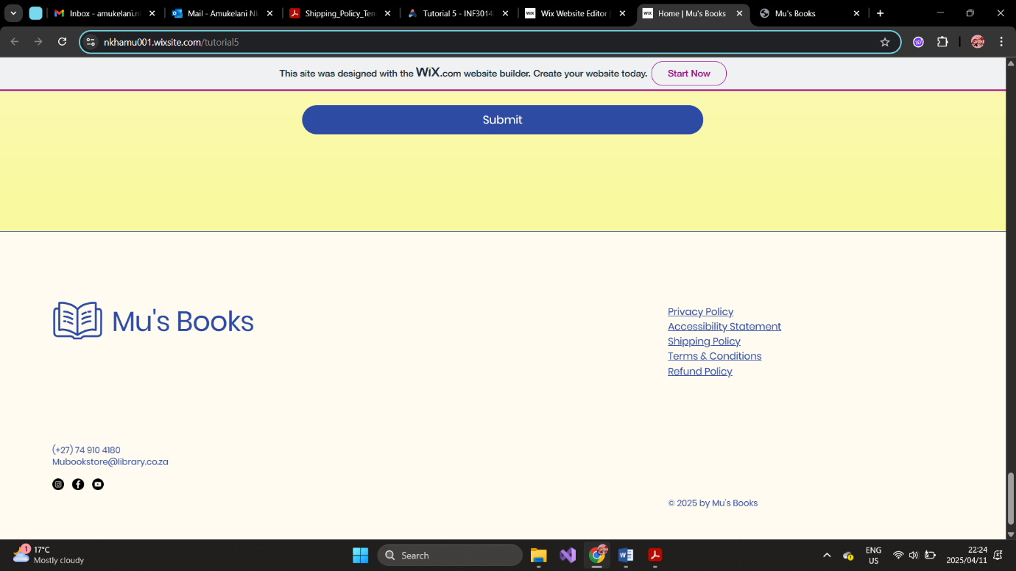

Figure 2: New Colour Scheme

Secondly, I added more high-quality images to showcase our range of products more vividly, making the site more engaging and dynamic.



Figure 3: Initial Site with a few product options

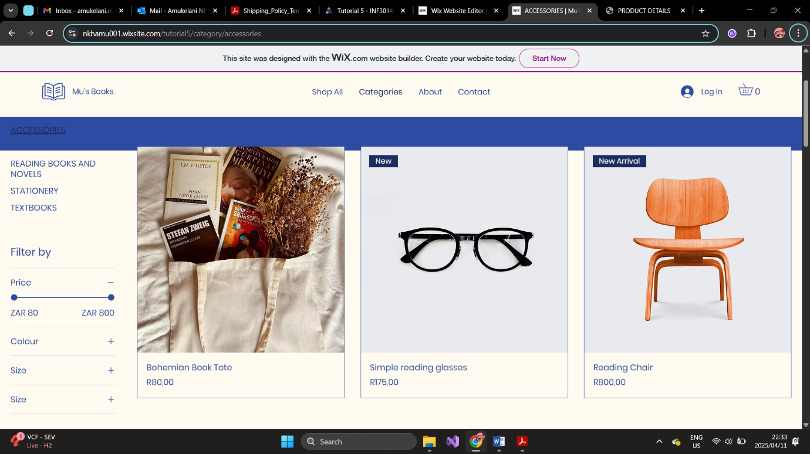

Figure 4: New Site with more variety and categories

Furthermore, I added more functionality such as the customer login option which created a more interactive and user-centred experience. I also introduced notebook and accessory customization options and a pre-order feature to improve user satisfaction and operational efficiency. These additions would have been technically demanding to implement with raw HTML and CSS alone.

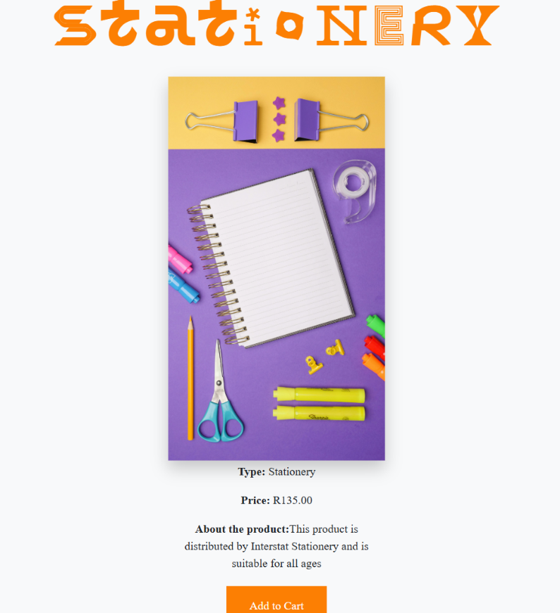

Figure 5: Initial product page and options

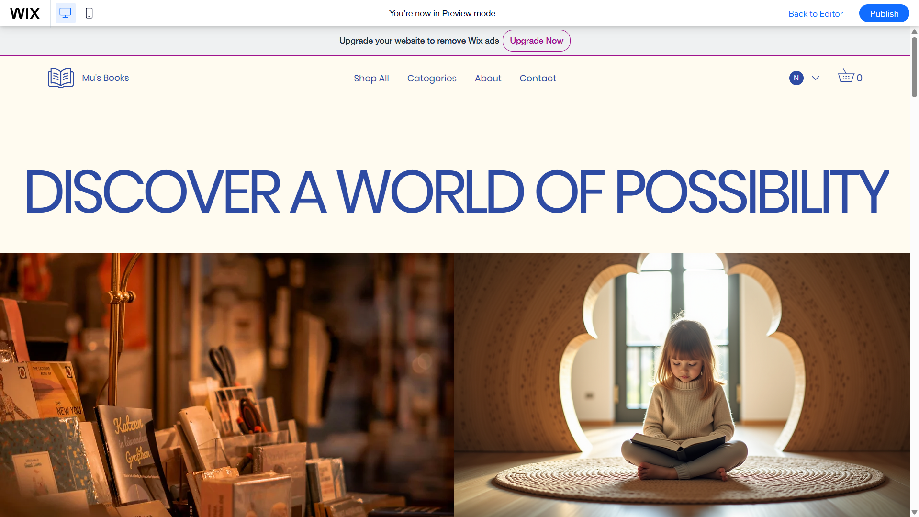

Figure 6: New banner with login icon

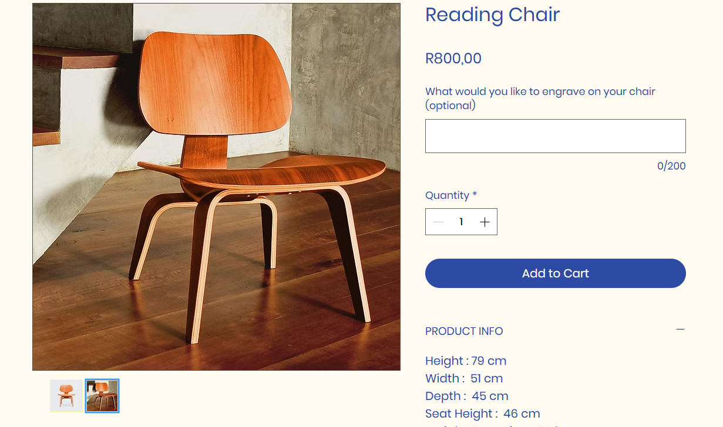

Figure 7: New product page with option to engrave and more product information

**How did CMS features (e.g., templates, drag-and-drop, animations, responsiveness tools) influence your design decisions?**

The Wix templates provided a starting outline that guided the layout while still offering me the flexibility to adjust spacing, images and the text. The drag and drop interface encouraged me to experiment with different placements, colours, and media without the fear of "breaking" the code. Additionally, the responsiveness tools allowed me to test how the site appears on different devices, ensuring accessibility for the users. Additionally, animations and the built in widgets (such as inventory tracking) added vibrancy and functionality, which would have otherwise required me to use external libraries or plugins if I were coding the website from scratch. Ultimately I would say that with technical constraints lifted, I could focus on exploring creative and customer friendly solutions by streamlining both design and operations.

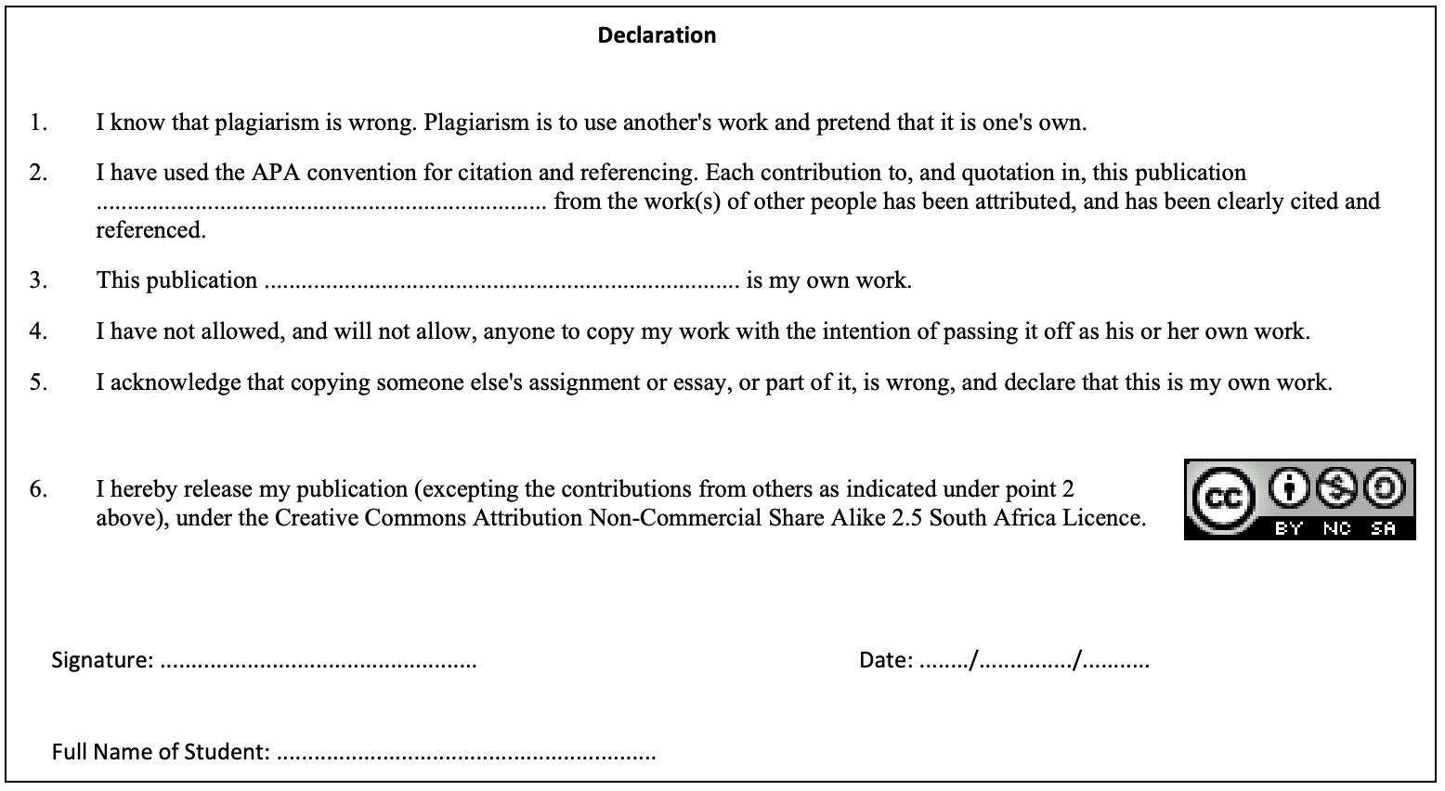

***Signature:*** *A. Nkhi*

***Name:*** *Amukelani Nkhi*

***Date:*** *11/04/2025*